# CHAPTER 1: INTRODUCTION

# 1.1 Introduction:

With electric cars driving into the country, the need of the hour is an efficient charging network. However, unlike petrol or diesel pumps, which have standardized nozzles for all types of vehicles, electric vehicles have different types of chargers for various types of vehicles.

Just like how mobile phones earlier had different types of chargers for different brands of phones, the electric vehicle space is going through a similar learning curve. The Indian government has mandated a certain type of charger for low-power electric vehicles, while the new breed of powerful electric SUVs has a different requirement.

However, that isn’t likely to be an issue. For example, MG Motor India has a tie-up with Finnish clean-energy company Fortnum to set up DC fast- charging stations across the country**.**

**1.1.1 Battery Charging Methods:**

Different methods employed for battery charging are as follows.

1.1.1.1 Constant Current Charging:

The constant current charging method adjusts the output voltage of charging devices or the resistance in series with the battery to keep the current constant. It uses a constant current value form the beginning to the end of charging. As nickel-cadmium batteries are easy to polarize during conventional charging, the electrolyte continuously produces hydrogen-oxygen gas in both Conventional constant voltage and constant current charging algorithms. Under the action of internal high pressure, the oxygen penetrates to the negative electrode, resulting in the decrease of effective capacity of the electrode plate. As the acceptable current capacity of the battery decreases gradually with the progress of the charging process, this led to the Overcharging of the battery in the later charging period. Eventually, it will also lead to a sharp drop in battery capacity.

* + - 1. Constant Voltage Charging:

Constant voltage charging is a widely used charging method involving constant voltage between the battery poles. The starter battery uses constant voltage charging when the vehicle is running. If the specified voltage constant value is appropriate, it can ensure that the battery is fully charged, while also minimizing gas and water loss.

* + - 1. Boost Charger CC/CV Charging:

The boost charger CC/CV charging algorithm is a further development of the constant current/constant voltage algorithms. Instead of using the constant voltage and current in the entire charging period, it boosts the charging efficiency through maximizing voltage in the first period, with the battery reaching approximately 30% of its nominal charging capacity. After this period, the charging algorithm is then switched to the standard CC/CV. Due to the initial higher charging voltage, the CC/CV can charge the battery faster than the CC/CV, but it is required to fully discharge the battery before charging. As the charger needs to provide variable voltage, all components need to accept the highest voltage generated by the boost charger. Discharging the battery before recharging is important as this will influence the efficiency charging algorithm and the life cycle of batteries.

* + - 1. Multistage Current Charging Algorithm:

Multistage current charging divides the entire charging period into several charging stages that attempt to use the optimal charging current across each stage, maximize the charging efficiency. By determining the optimal charging current for each stage, the fuzzy controller is used to determine the charging current by the change in temperature. To sum up, this algorithm is based on a micro- controller or a computer. The charging speed is faster and charging efficiency is higher than those of the CC/CV.

1.1.1.5 Inductive Charging:

Non-contact charging utilizes magnetic resonance to transfer energy in the air between the charger and battery. This achieves a highly efficient energy transformation.

As the non-contact charger could keeping charging the vehicle, it allows EVs to have a smaller battery. By itself, it is more economical, safer and more sustainably developed. Since the battery is the major contributor to the cost of an EV, the MSRP of an EV is lowered as a result of the use of non-contact charging. However, developing a non-contact charging system involves huge financial support. For example, to realize real-time charging on the road, it requires installation of receiver coil under the car and reconstruct the road and put transmitter coil under the power supply track. In this way, it allows car to be automatically charged while operating on the road. Due to this, many EV manufacturers are using traditional charging methods to keep costs low. Since non-contact charging systems rely on the electromagnetic field as their mechanism of action, electronic devices in close proximity to the charger may be negatively affected during charging. There is also the possibility that animals may be influenced. Efficiency is another concern for researchers.

**1.1.2 Types of Battery Charging:**

Battery Charging is broadly classified as AC & DC charging according to the type of supply.

1.1.2.1 AC Charging:

AC charging is the simplest kind of charging to find – outlets are everywhere and almost all EV chargers you encounter at homes, shopping plazas, and workplaces are Level 2 AC chargers. An AC charger provides power to the on-board charger of the vehicle, converting that AC power to DC in order to enter the battery.

The acceptance rate of the on-board charger varies by brand but is limited for reasons of cost, space and weight. This means that depending on your vehicle it can take anywhere from four or five hours to over twelve hours to fully charge at Level 2.

1.1.2.2 DC Charging:

DC Fast Charging bypasses all of the limitations of the on-board charger and required conversion, instead providing DC power directly to the battery, charging speed has the potential to be greatly increased. Charging times are dependent on the battery size and the output of the dispenser, and other factors, but many vehicles are capable of getting an 80% charge in about or under an hour using most currently available DC fast chargers.

DC fast charging is essential for high mileage/long distance driving and large fleets. The quick turnaround enables drivers to recharge during their day or on a small break as opposed to being plugged in overnight, or for many hours, for a full charge.

Older vehicles had limitations that only allowed them to charge at 50kW on DC units (if they were able to at all) but newer vehicles are now coming out that

Can accept up to 270kW. Because battery size has increased significantly since the first EVs hit the market, DC chargers have been getting progressively higher outputs to match – with some now being capable of up to 350kW.

Currently, in North America there are three types of DC fast charging: CHAdeMO, Combined Charging System (CCS) and Tesla Supercharger. All major DC charger manufacturers offer multi-standard units that offer the ability to charge via CCS or CHAdeMO from the same unit. The Tesla Supercharger can only service Tesla vehicles, however Tesla vehicles are capable of using other chargers, specifically CHAdeMO for DC fast charging, via an adapter.

# Chapter 2: LITERATURE SURVEY

* The importance given to the market integration of PHEV and EV resulted in “Design and simulation of fast charging station for PHEV and EV batteries “was presented by G. JOOS and M.DE. FREIGE in 2010 [1].
* The charger is an important for “Transformer less high voltage and controllable current battery charger for E-CAR " was presented by P.S. PRIMBODO and W. PURNOMO in 2013 [2].
* The carbon emission minimization is one of the big challenges in the country for "Design and Simulation of wireless stationary changes for hybrid electric vehicles using inductive power pad in parking garage" was presented by M. RUHUL AMIN and R.B.ROY in 2014 [3].
* The analysis and design of a switch mode DC-DC boost converter like "a compensated voltage control storage for the DC-DC boost converter in a solo battery charger" was presented by D. MORRIS and R. GHALI in 2017[4].
* This paper proposes a single phase 3.3KW on board battery charger for " Design and development of on-board DC fast charger for E. RICKSHOW " was presented by A. DIXIT and K. PANDE in 2019[5].
* This paper presents the study of a 100KW electric vehicles [EV] fast charger based on “12 pulse rectifier with DC side buck converter for electric vehicles fast charging” was presented by D.LAN and T.B. SOBIRO in 2022[6].

## Chapter 3: Principle and Working

**3.1 Concept of Project**

EV batteries store charge in the form of DC power, while the electric grid supplies alternating current (AC) power. When you use Level 1 or Level 2 charging, your EV receives AC power that must be converted to DC before it can be stored in your car’s battery. To do this, your EV has an on-board charger. DC fast charging, though as its name implies, provides DC power straight to your EV’s battery; the AC-to-DC conversion happens in the charging station before the electrons enter your vehicle. That’s why DC fast charging is able to provide a much faster charge than Level 1 or Level 2 charging. The concept of this project is to design a MATLAB Simulink model for DC fast charger which is capable of charging EV batteries. Control algorithms of DC fast charger are implemented in such a way that, depending upon State-of-Charge (SOC) of battery the charging method is adopted. If battery SOC is less than 80%, then DC fast charger will implement Constant Current (CC) charging and for SOC more than 80% it will go for Constant Voltage (CV) charging.

DC fast chargers are capable of charging the battery up to its full capacity within 1-2 hours. This will reduce charging time of battery which is about 6-8 hours in case AC charging of battery. [7]

**3.2 Need of Project**

More specifically, it is challenging in the current scenario to refuel an electric vehicle (EV) compared to a gasoline-powered one. Unlike the latter, with not very frequently available EV charging stations, it is still a tough row to hoe for the driver to replenish the car for the desired travel commute. It takes quite of an effort to reach an EV station and bear the patience to charge an electric car.

In technical terms, the most critical factors involved in the EV charging process are the compatibility between the vehicle and charger and the time invested in charging.

EV charging is no different than any electric gadget that undergoes a charge. The mechanism remains the same. Power is drawn from the grid to the charger plugged into the device.

Similarly, the power is transferred from the grid to the charger in an electric car and eventually flows into the vehicle.

The thumb rule remains the same for the power drawn from the grid, which is AC, however, the final source, i.e., the battery, stores current in DC form only. Hence before commencing the charging operation for an EV, it is essential to be cognizant of the type of charger being used.

**3.2.1 AC Chargers:**

An AC charger is always coupled with a built-in setup with an AC charging infrastructure, known as the on-board charger. The role of an on-board charger is energy conversion from AC to DC and supply the current to the heart of the EV, i.e. the battery pack.

AC charging also referred to as ‘Slow Charging’ is the most common form of charging due to the high charging point availability and ease of installation. AC chargers can be installed at home (type 1) or are readily present at the EV charging stations (type 2). A range anywhere between 22kW-43kW per km/h is achieved with fast AC chargers.

Depending upon the intake capacity of the on-board charger, it may take a couple of hours or overnight to full-charge an electric car.

But AC charging of battery is having following limitations

1. Charging is slower over time due to much more losses during conversion from AC to DC.

2. Cannot be as fast as a DC charger.

3. Every vehicle has to carry on board charging circuitry.

4. Interconnection with renewable energy sources might require complex conversion circuits.

5. Battery charging up to full capacity may require 8 to 12 hours of time.

6. Due to high charging period, it is not suitable for large fleets.

However, DC fast chargers can overcome all the drawbacks of AC chargers. Hence we are developing DC fast Charger for battery charging.

**3.3 Software Simulation**

As we are developing MATLAB Simulink model for DC Fast Charger we will require following components.

Apparatus: Desktop/ Laptop with MATLAB Simulink software Sub-System

* + 1. **Three Phase Power Supply Sub-System**

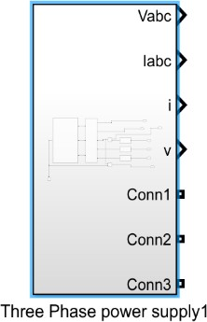

Fig 3.1 Three phase power supply

Blocks Required:

1. Three Phase Programmable Voltage Source
2. Three Phase V-I Measurement
3. Series R-L Branch
4. Voltage Measurement
5. Current Measurement

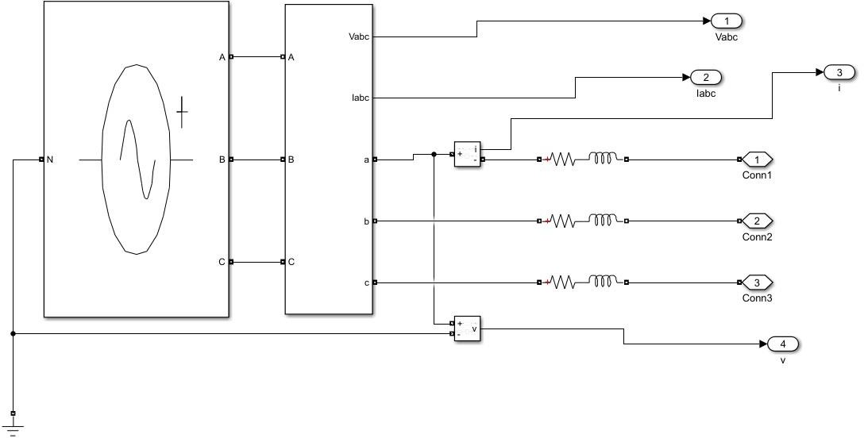

Fig.3.2 Three phase power supply sub-system

* + - 1. Three Phase Programmable Voltage Source

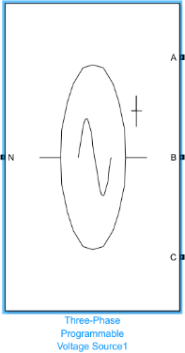

Fig 3.3 Three Phase Programmable Voltage Source

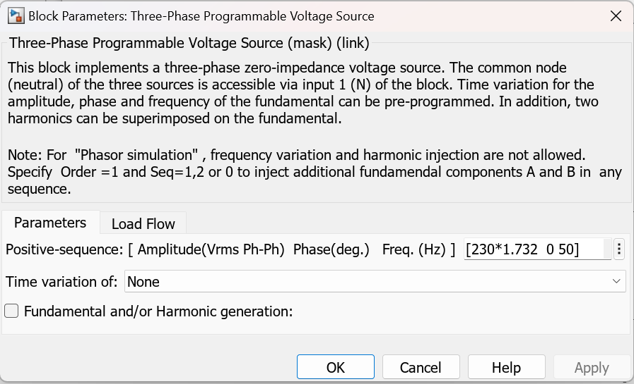

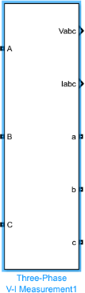3.3.1.2. Three Phase V-I Measurement

Fig 3.4 Three Phase V-I Measurement

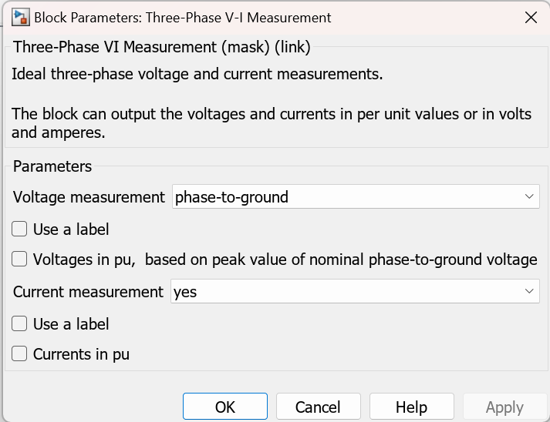

3.3.1.3. Series R-L-C Branch

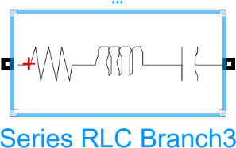

Fig 3.5 Series RLC Branch

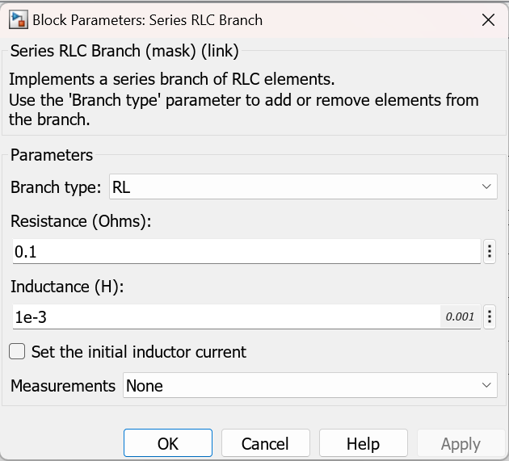

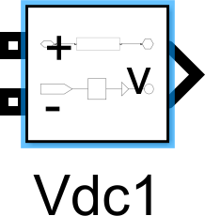3.3.1.4. Voltage Measurement

Fig 3.6 Vdc

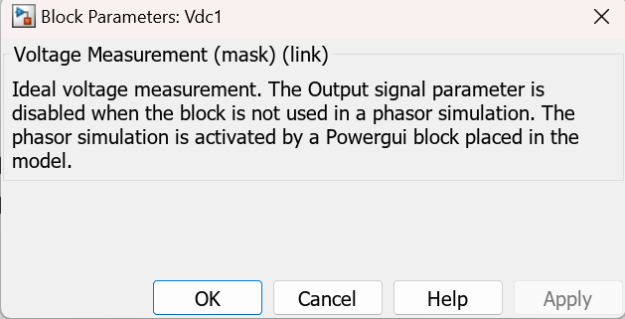

3.3.1.5. Current Measurement



Fig 3.7 Current Measurement

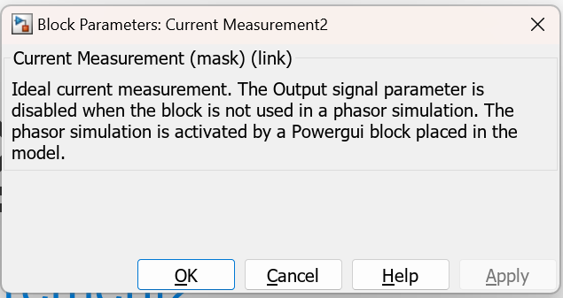

* + 1. **AC – DC Converter Sub System**

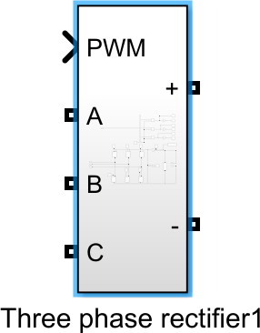

Fig 3.8 Three Phase Rectifier

Blocks Required:

1. MOSFET
2. Repeating Sequence
3. Demux
4. Relational Operator
5. NOT gate
6. Current Measurement
7. Voltage Measurement

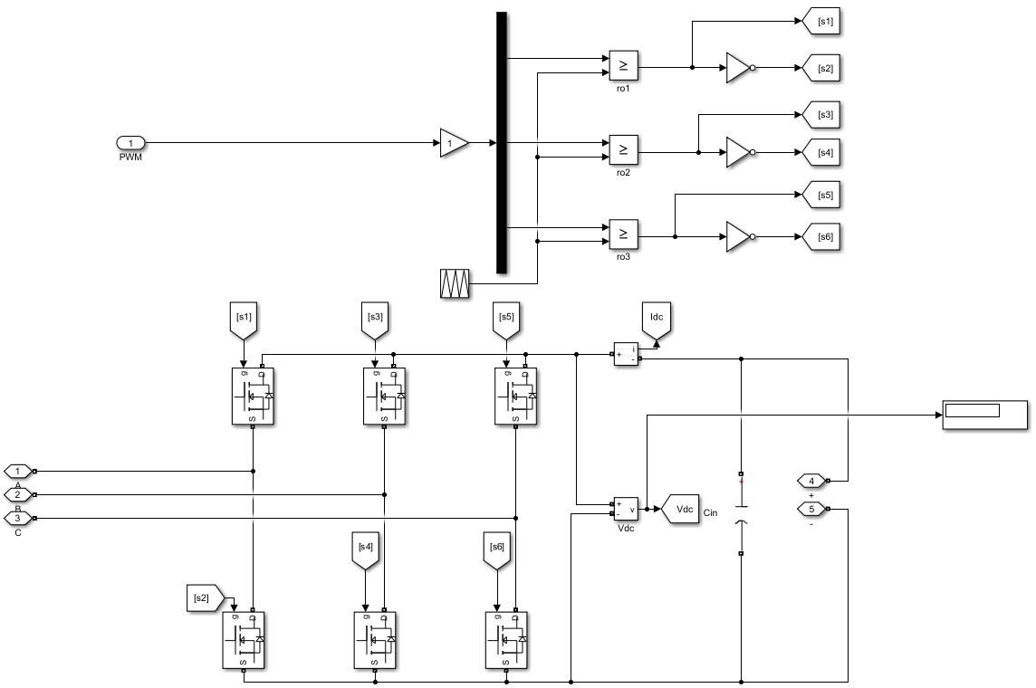

Fig. 3.9 AC-DC converter sub-system

* + - 1. 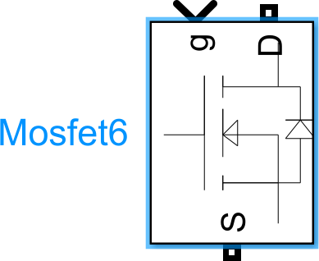MOSFET

Fig 3.10 Mosfet

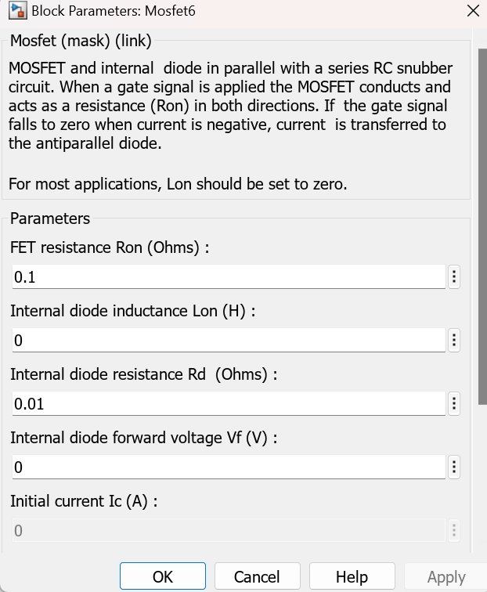

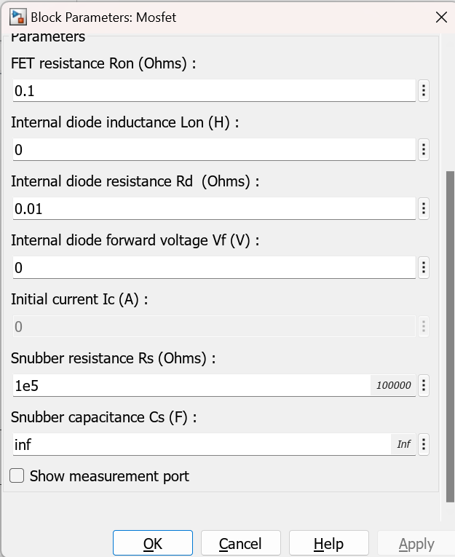

3.3.2.2. Repeating Sequence

Fig 3.11 Repeating Sequence

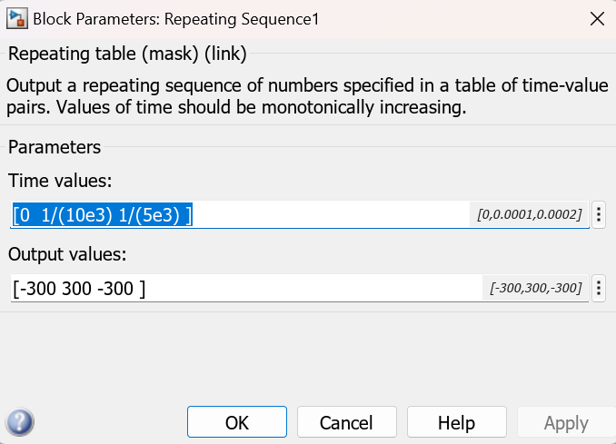

3.3.2.3. Demux

Fig 3.12 Demux

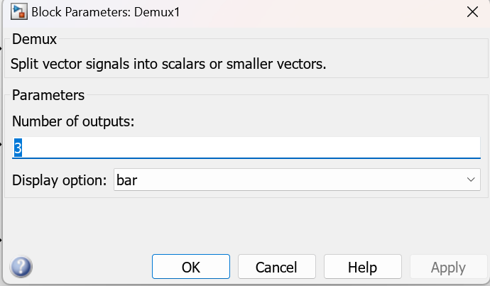

3.3.2.4. Relational Operator

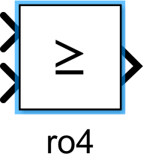

Fig 3.13 Relational Operator

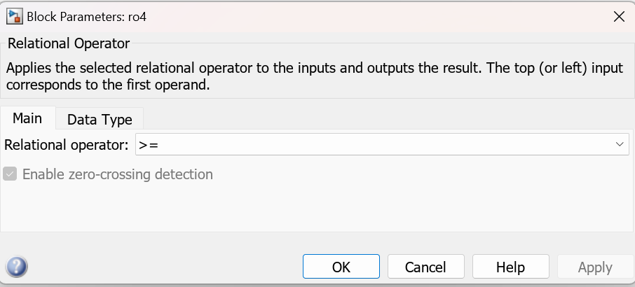

3.3.2.5. NOT gate



Fig 3.14 Not Gate

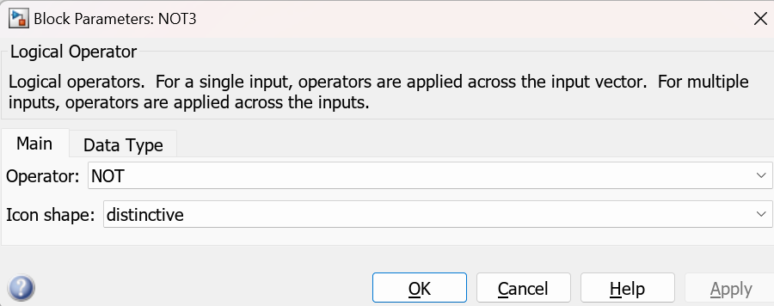

3.3.2.6. Current Measurement



Fig 3.15 Current Measurement



3.3.2.7. Voltage Measurement



Fig 3.16 voltage Measurement



**3.3.3. Closed Loop Control System**

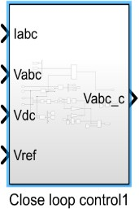

Fig 3.17 Close loop control

Blocks Required:

1. MUX
2. DEMUX
3. Add Block
4. Gain Block
5. PID Controller
6. ABC to dq0
7. dq0 to abc

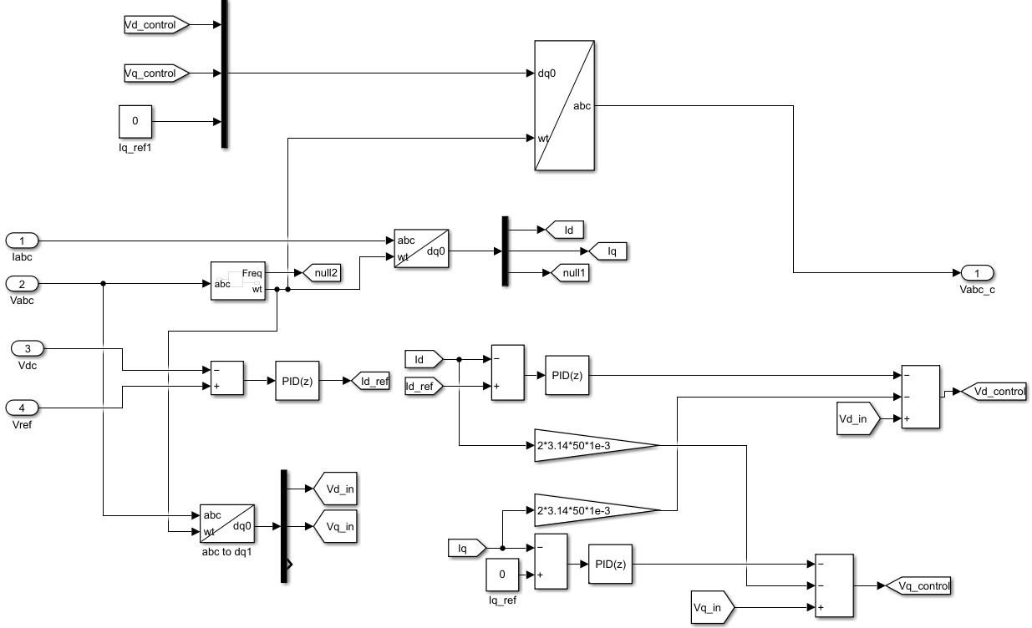

Fig 3.18 Simulation Diagram

* + - 1. MUX

Fig 3.19 MUX

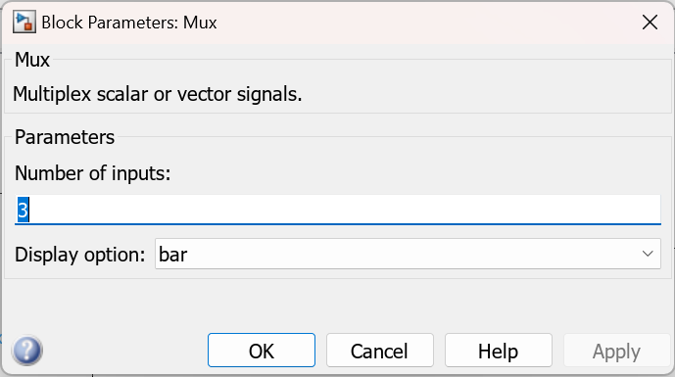

3.3.3.2. DEMUX



Fig 3.20 DEMUX

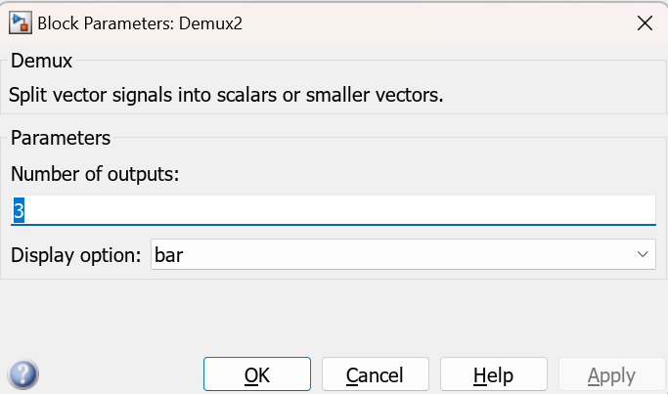

3.3.3.3. Add Block

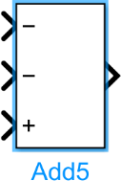

Fig 3.21 Add block



3.3.3.4. Gain Block

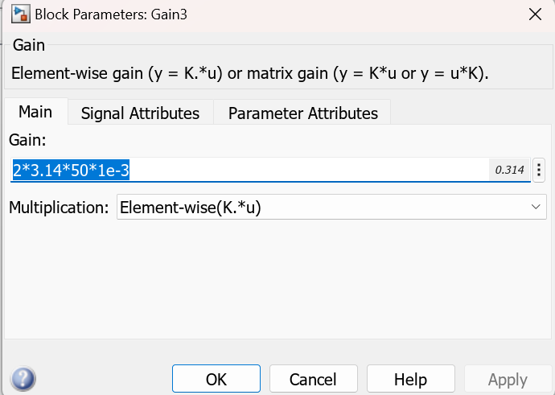

Fig 3.22 Gain Block

3.3.3.5. PID Controller

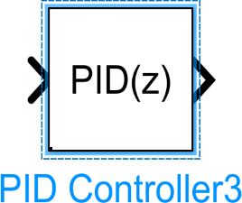

Fig 3.23 PID controller

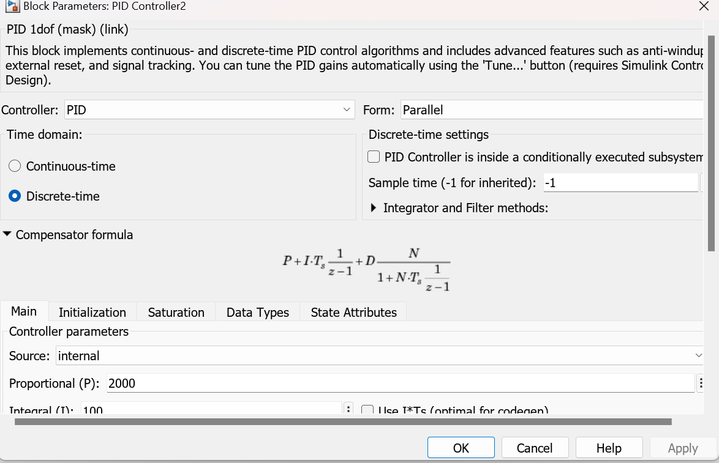

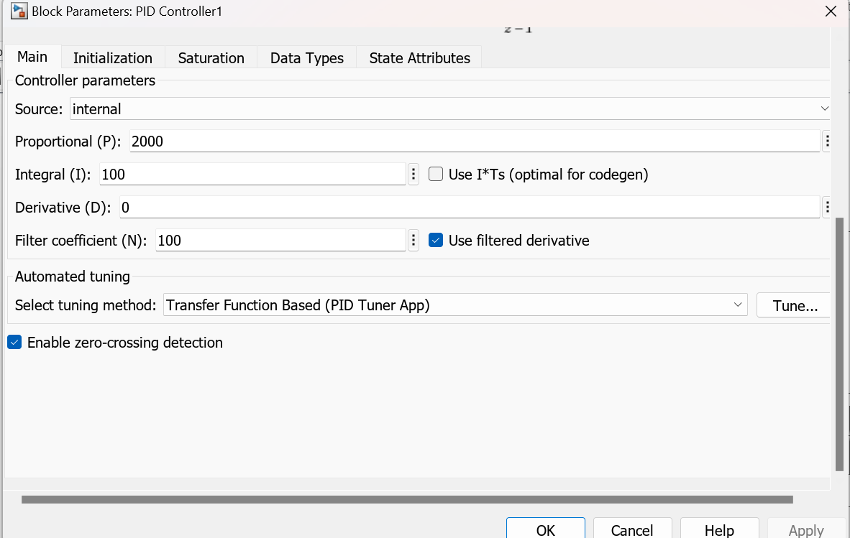

3.3.3.6. ABC to dq0

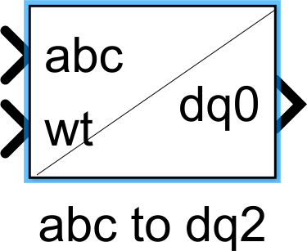

Fig 3.24 abc to dq0

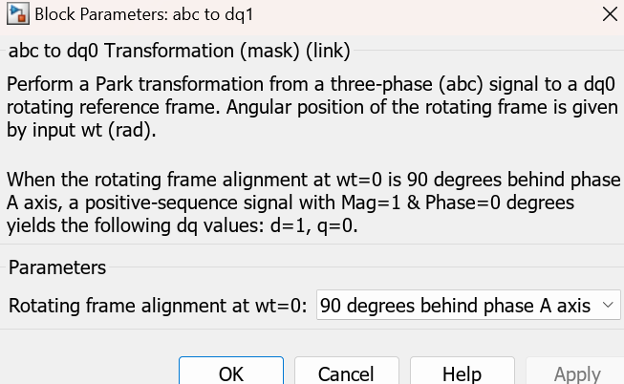

3.3.3.7.dq0 to abc

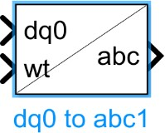

Fig 3.25 dq0 to abc

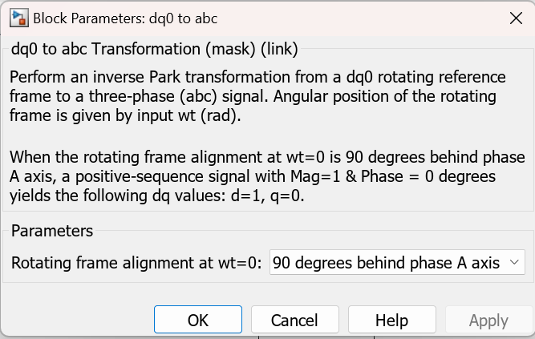

**3.3.4. Diode**

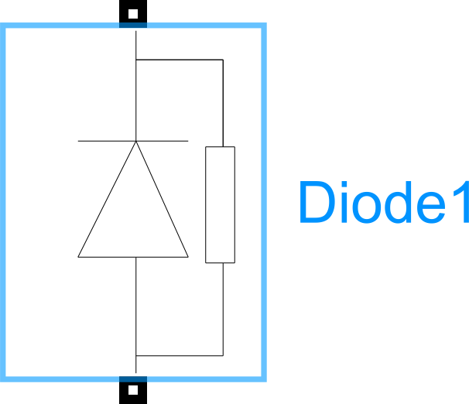

Fig 3.26 Diode

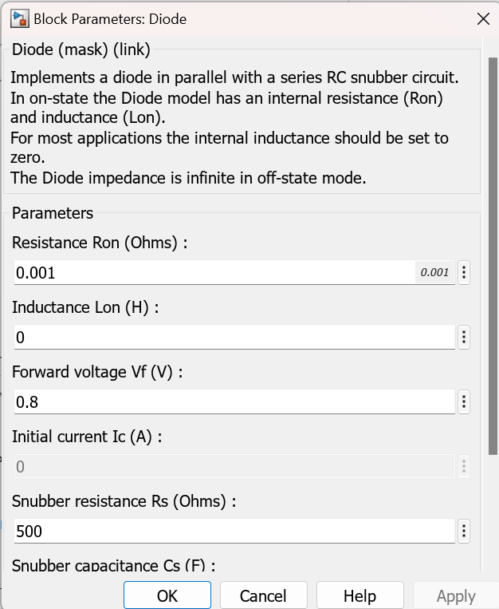

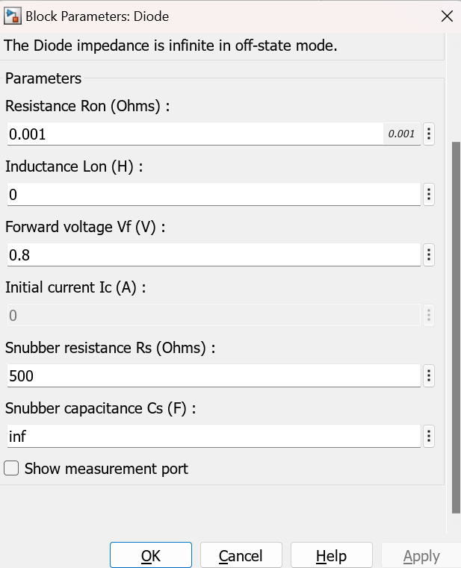

**3.3.5. PWM Generator**

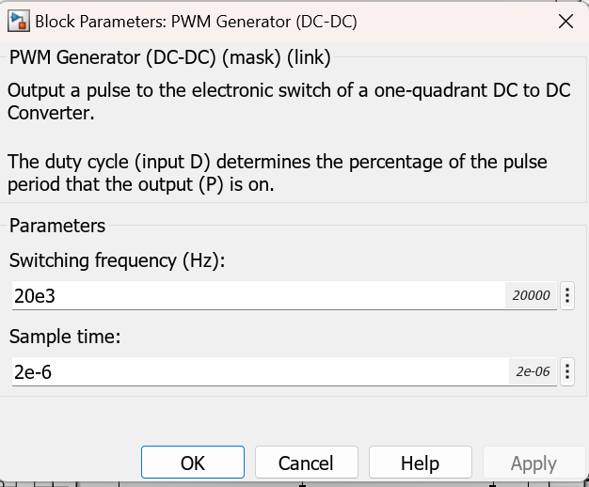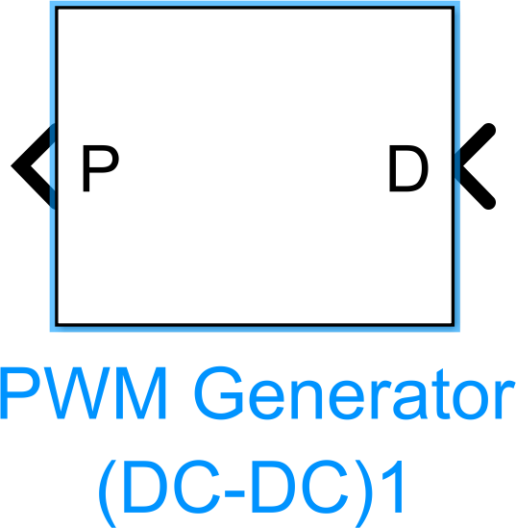

Fig 3.27 PWM Generator

**3.3.6. Saturation**

Fig 3.28 Saturation

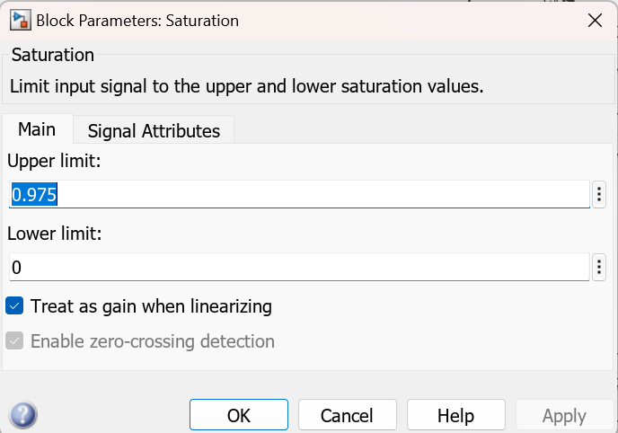

**3.3.7. MATLAB Function Block**

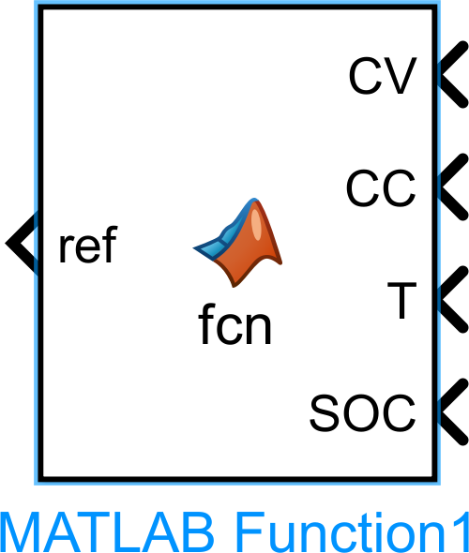

Fig 3.29 Matlab Function



**3.3.8. Series RLC Branch**

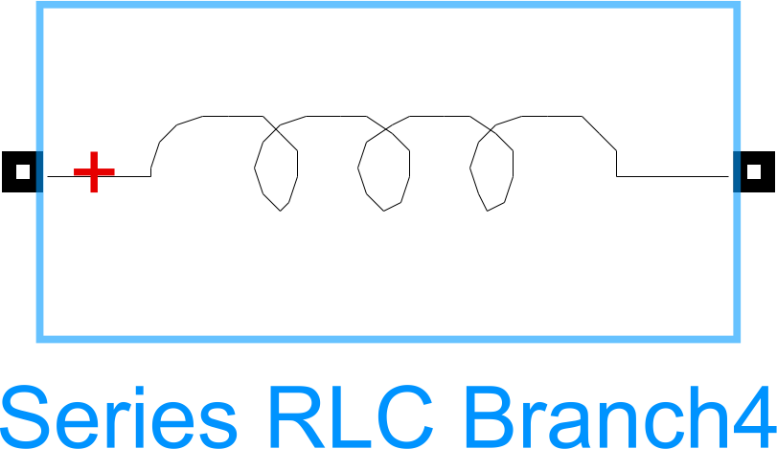

Fig 3.30 Series RLC Branch

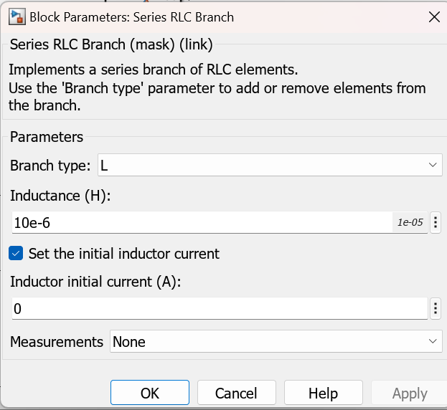

**3.3.9. Battery**

# 

# Fig 3.31 Battery

# 

# 

### **Chapter 4: Simulink Model**

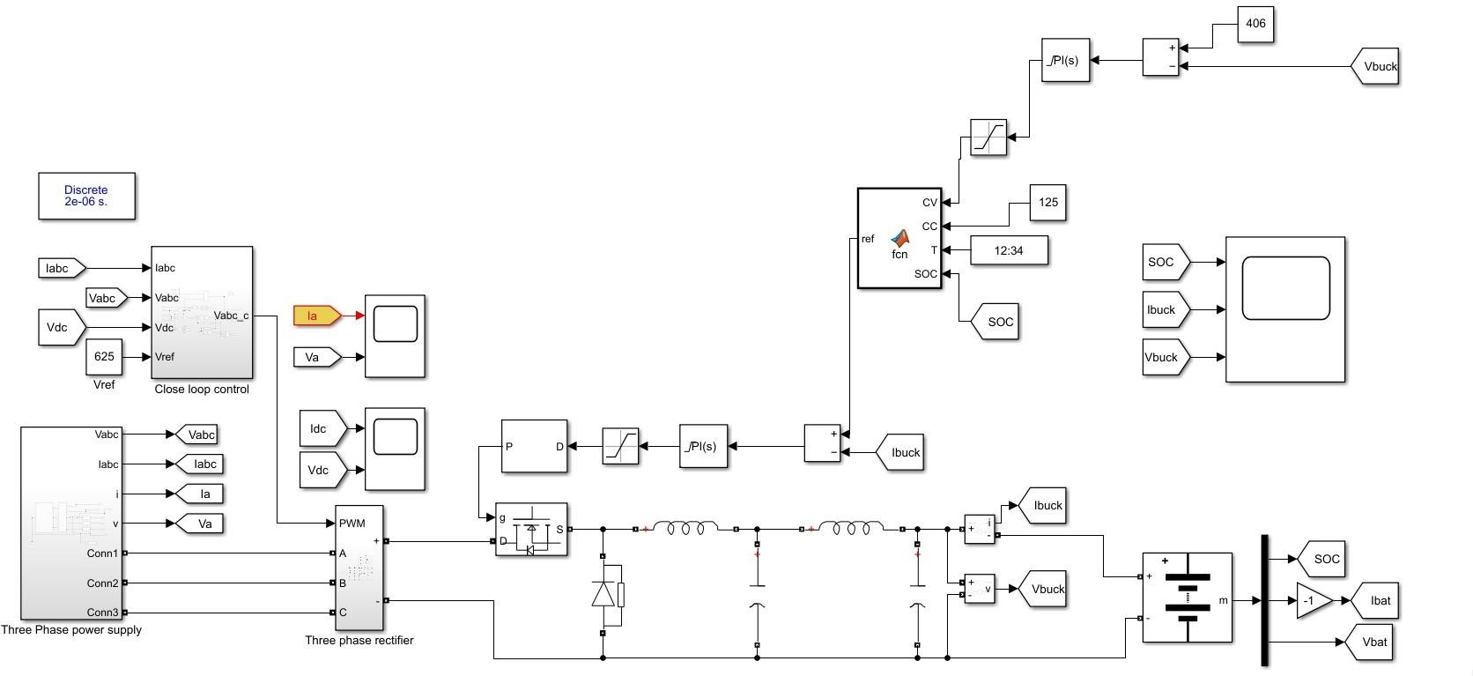

Fig. 4.1 MATLAB Simulink model

Above figure shows complete MATLAB Simulink model for DC Fast Charger.

**Chapter 5: Advantages, Disadvantages and Future Scope**

**5.1 Advantages**

**1. Zero emissions**

Cars that are 100% electric and use DC fast charging stations do not emit polluting gases.

**2. Decrease Charging Time**

DC fast chargers are significantly faster than regular AC charging stations taking between 15 and 45 minutes to charge most passenger electric vehicles up to 80 percent making it quick and easy to charge on the go**.**

**3. Gain Loyal Customers**

As EV adoption increases, EV drivers are looking for reliable places to charge. For businesses targeting this well-to-do market segment, EV charging is a powerful way to gain new customers and have them return on a regular basis.

**4. Drive Sustainable Change**

With more DC fast charging stations available, one of the main barriers to electric vehicle adoption range anxiety is reduced.

**5. Can Provide Super-Fast Charging**

Are extremely scalable and can deliver higher amounts of power consistently during a charging period.

**6. Can support renewable Energy Sources**

Renewable energy sources like solar photovoltaic generation can be used as a power source**.**

**5.2 Disadvantages**

1. DC fast chargers are bigger in size and more complex.

2. Setting up and manufacturing DC chargers also takes more effort and resources.

3. It also costs a lot more than AC chargers.

4. DC charging creates a diminishing charging curve due to the EV’s battery initially accepting a quicker flow of power but gradually asking for less as it reaches full capacity.

5. Fast charging may not work well in areas of extreme heat, especially if the batteries are passively cooled.

6. Fast charging generally tends to reduce a battery’s life quicker than slow charging, so repeated usage of this technology may not be good for the battery’s health.

**5.3 Future Scope**

The EV charging station market is expected to grow 5 to 7 times in the next 5 years. It was valued at 5 billion dollars in 2020 and optimistic predictions see it reach around 35 billion by 2026, which would make EVs represent 15% of all car sales worldwide within 5 years.

In the following years the cars charging voltage will be increased from 500V to 800V, also the power of a single charger will increase to 350kW compared to the current 60kW. In practice, this means charging time will be shortened from about 1 hour to 10 – 15 minutes.

Publicly accessible fast chargers facilitate longer journeys. As they are increasingly deployed, they will enable longer trips, encourage consumers that lack access to private charging to purchase an EV, and tackle range anxiety as a barrier for EV adoption.

DC fast charging infrastructure will also provide great employment opportunities to electrical, electronics and power engineers.

However, the demand for EV charging infrastructure will be affected by the factors such as costing, public transportation, framework of policies and regulations and rate of EV adoption.

**Chapter 6: Result**

DC fast charger operation can be classified into two categories as follows.

* + 1. For Battery State-of-Charge (SOC) below 80% :

Under this condition DC fast charger will provide constant current charging. The magnitude of charging current is about 125 A and batter charging voltage is 400 V.

* + 1. For battery State-of-Charge (SOC) above 80% :

Under this condition DC fast charger will provide constant voltage charging. The magnitude of charging current is 25 A and that of charging voltage is 395 V.

**Simulation result:-**

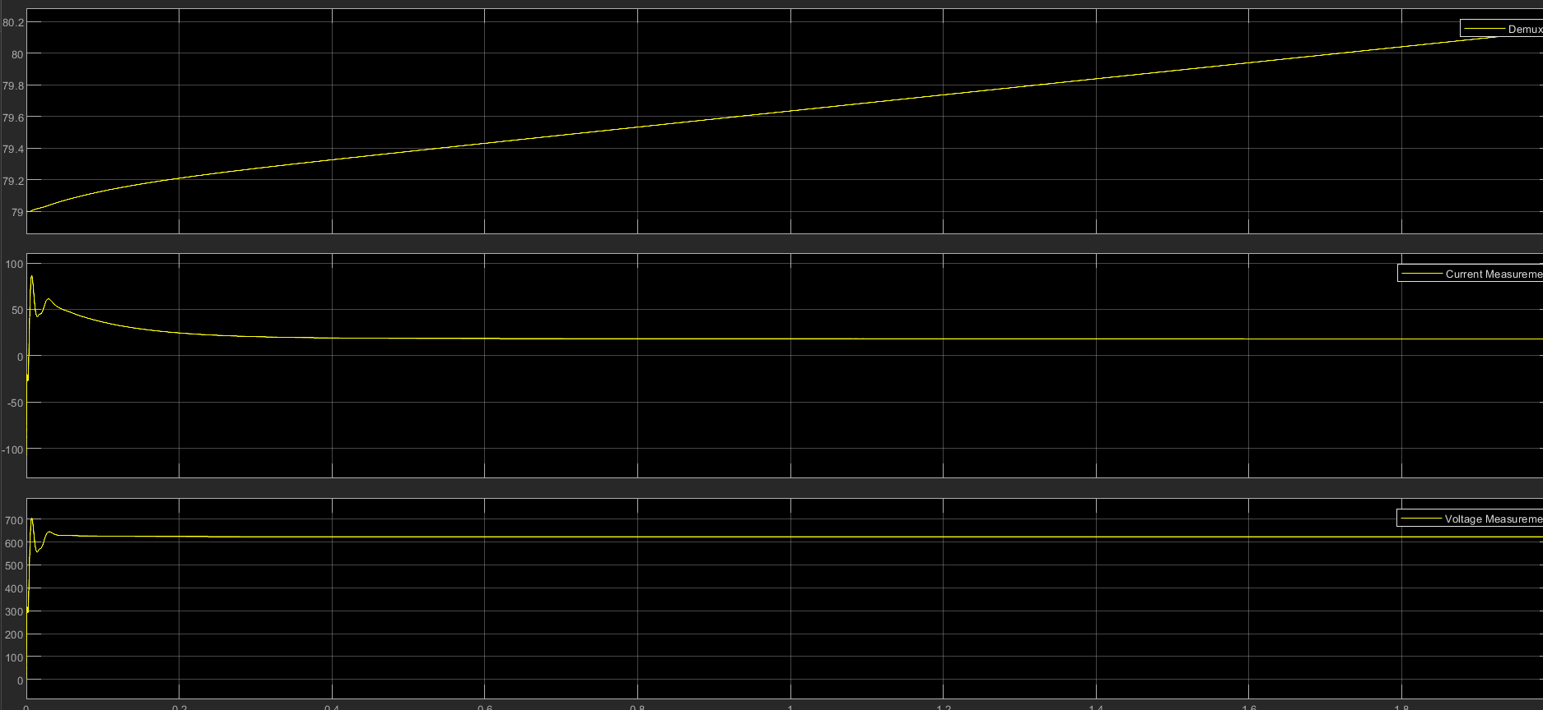

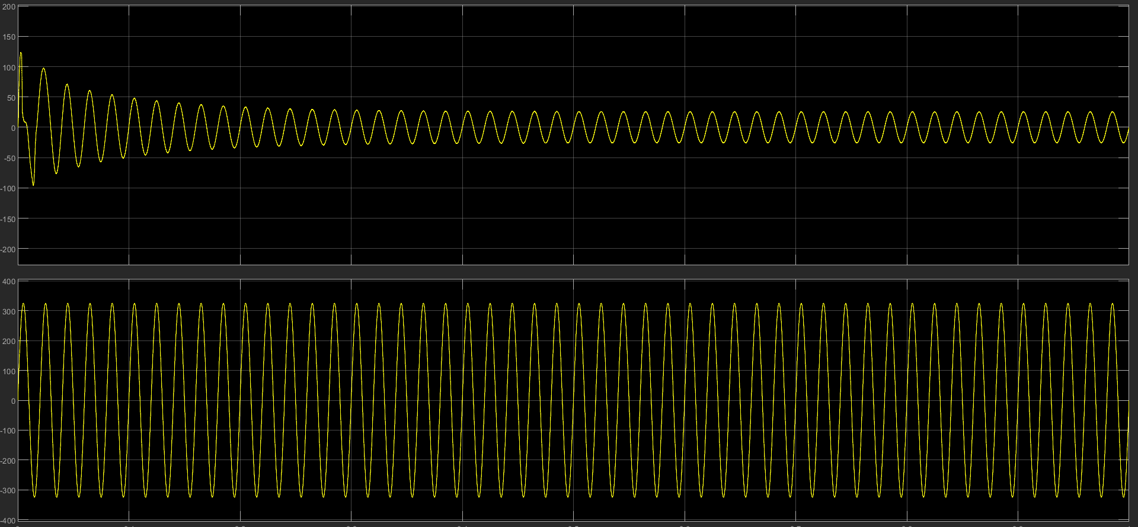

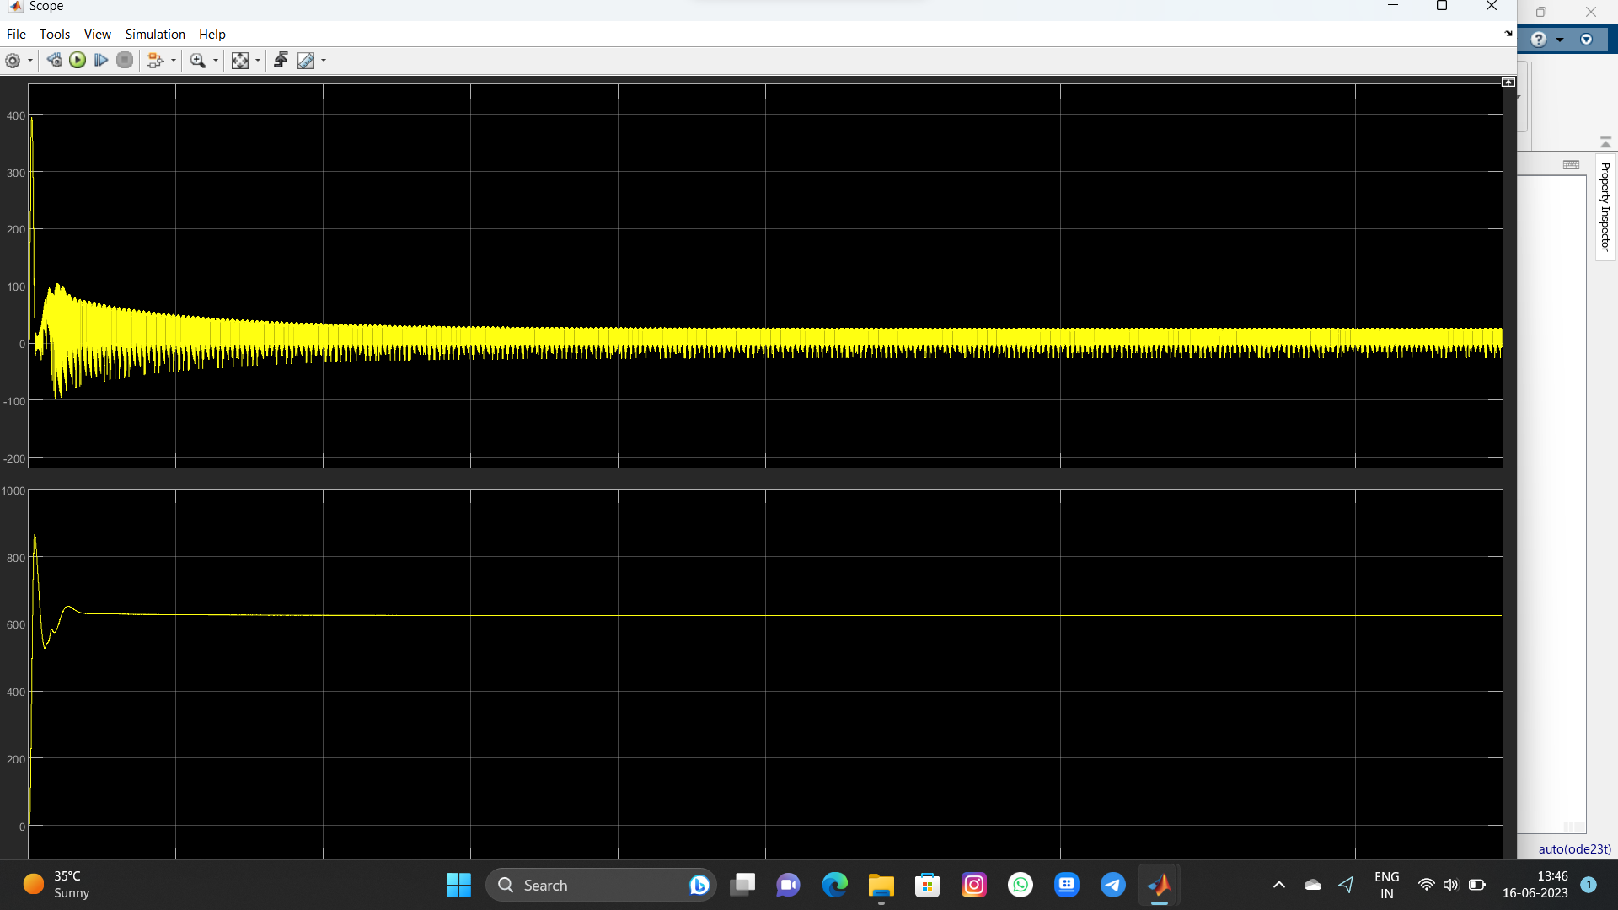

**Chapter 7: Conclusion**

Increasing environmental problems in recent years, transformation in energy systems. Digitalization are the issues that affect the transition to EV’s the most. From this point of view, one of the most important in the transition to EVs, the integration of charging units to the grid, has been discussed. DC fast charging units come to the fore due to the need for high power energy as the charging time needs to be shortened in order for EV’s to be more preferred. In this study, DC Fast charging it for EV’s was modelled in MATLAB Simulink environment

In the modelling, the power coming from the network creates a DC bus line through the AC/DC converter. The DC bus line represents the stage required for charging the EVs. All EV’s to be connected to the charger will draw power from the DC bus. As the number of EV’s to be connected to the grid increases the fluctuations on the DC bus will also increase. In order to keep these fluctuations at a certain level, adding a capacitor is necessary to keep the fluctuations at the desired level. Keeping the fluctuations at a certain level has shown that more effective results are obtained in EV charging. The reason of this. While the battery inside the EV is charging, the infinite charging process will damage the EV battery. It is important to identify these uncertainties. According to the nominal values of the battery’s charging current and voltage, it is necessary to determine cut-off voltage, full charge voltage, discharge current, main current values and to determine the current and voltage values for the DC bus apply**.**

In order to keep the mentioned values at the specified levels, control design is required. The charger charges the EV battery using the power it receives from the AC-DC converter. The part that will control this process is the battery charge controller. The inverter takes the power from the grid and feeds the DC bus after AC/DC conversion. The part that will control this process is the inverter controller.

Battery charge control and inverter control design means controlling the transition of power from the electrical power system to the EV battery. By including these control designs in the model, battery charge and DC bus voltage are kept at desired levels. In the study, the design was carried out using the constant current strategy in battery charge control and the dq conversion conventional strategy in inverter control. In addition different inverter control strategies were mentioned in the design, and battery charge control was designed in accordance with the constant current-constant voltage strategy. A system model is presented in which different control strategies can be applied.

When the results are examined, the battery voltage value fits into the full charge voltage value determined within the framework of the nominal parameters entered to the battery. The voltage increases continuously up to this level and ensures that the current is kept constant. The current value, on the other hand, provides a constant current value based on the discharge current value determined within the framework of the entered nominal parameters. With the implementation of the strategy, the current value will decrease after the voltage settles to the full charge voltage and it will perform the charging process at higher current. In this way. High current will support faster charging. Thus, it has been determined that with the development of control strategies, high-speed charges will be paved. It is recommended to carry out studies by examining the power quality on the grid while charging at high speeds.

# REFERENCES

[1] G. JOOS and M.DE. FREIGE “Design and Simulation of fast charging station for - PHEV/EV batteries” IEEE electrical power and energy conference for 2010, PP (1-3).

[2] P.S. PROMBODO and W. PURNONOMO “transformer less high voltage and controllable Current battery charger for E-CAR” IEEE joint international conference on 2013, PP (1-4).

[3] RUHUL AMIN and R.B.ROY “Design and Simulation of wireless stationary charging s/m” IEEE the 8th international conference on software for 2014, PP (1-5).

[4] D. MORRIS and R. GHALI "A compensated voltage-mode control strategy for a DC-DC boost converter in a solar battery charger" for IEEE Green Energy and Smart Systems Conference (IGESSC) on 2017, PP (1-6).

[5] A. PANDE and K. DIXIT “a compensated to voltage mode control of Design and development of on board DC fast charger for E.RICKSHOW” for IEEE green energy and smart system. 2017 PP (1-6).

[6] D.LAN and T.B. SOBIRO “12 pulse rectifier with DC side buck converter for electric vehicles fast charging” on 48 annual conferences of the IEEE industrial 2022 PP (1-6).

[7]K.W.KLONTZ AND D.W.NOVOTNY “Universal Inductive Interface for Electric Vehicle Charger system”, on power conversion international conference 2014 PP (2-4).